Challenge 1: The first challenge (Challenge1.pcap) asks us to find the username and password login credentials

The first thing we do is look for any form of login since the challenge says to look for login creds, using the protocol feature, we straight away see the TELNET protocol sitting there

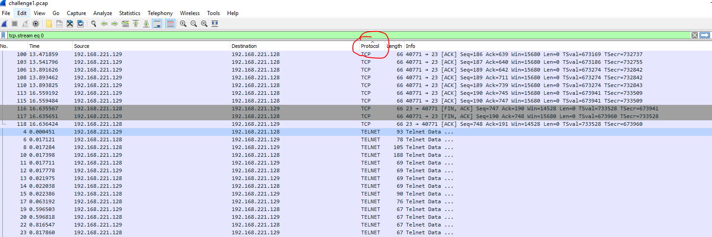

The next stage is to follow the TCP stream, you can clearly see the login attempt, with the following credentials in the stream

Bt login: ccssaaww

Password: welcome to 1969

